Lab 08

Kalubowila G.N

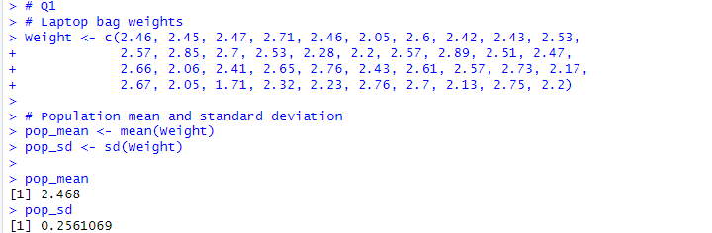1)

2)

3)

